SHERBORNE TENNIS CLUB KIT

If you would like to order some STC kit please email Kerry Mullen on kerrynmullen@gmail.com and she will help you to place an order.

Hoodie
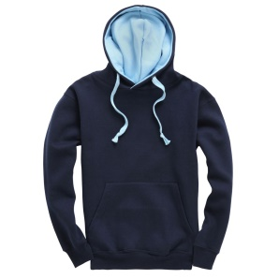
Navy hoodie with sky inner hood liner
Sherborne Tennis Club logo on the front
Sherborne Tennis Club on the back in sky

Cost
Adults £28.50
Juniors £26.50

Adult Sizes
To fit chest size | 34” | 37” | 40” | 43” | 46” | 50” | 53”
Order as | XS | S | M | L | XL | XXL | XXXL

Junior Sizes
To fit chest size | 29” | 32”
Order as | 7-8 years | 9-11 years

Sweatshirts
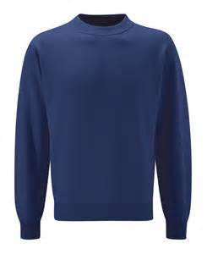
Navy sweatshirt
Sherborne Tennis Club logo on the front
Sherborne Tennis Club on the back in sky

Cost
Adults £28.00
Juniors £11.00

Adult Sizes
To fit chest size | 34-36” | 36-38” | 38-40” | 40-42” | 42-44” | 44-46” | 46-48”
Order as | XS | S | M | L | XL | XXL | XXXL

Junior Sizes
To fit chest size | 22-24” | 26-28” | 30” | 32”
Height | 104cms | 116cms | 128cms | 140cms
Order as age | 3-4 | 5-6 | 7-8 | 9-11

Polo shirts
There are two types of Polo shirts, both in Navy.
One type is a performance material.
The other is a poly cotton material.
Additionally, there are men’s and women’s cut in each option…please take care when you order.

Performance Polo Shirt
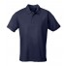
Navy ‘Cool’ performance shirt – 100% polyester
Sherborne Tennis Club logo on the front
Sherborne Tennis Club on the back in sky
Men’s cut & women’s cut available
Juniors are unisex cut only

Cost
Adults £20.00
Juniors £19.00

Men’s Sizes
To fit chest size | Age 12 - 13 | 38” | 40” | 43” | 45” | 48”
Order as | Junior XL | S | M | L | XL | 2XL

Women’s Sizes
To fit size | 33” | 34” | 36” | 38” | 40” | 42” | 44”
Order as size | 08 | 10 | 12 | 14 | 16 | 18 | 20

Junior Sizes
To fit chest size | 26” | 28” | 30” | 32” | 34”
Order as | 3-4 years | 5-6 years | 7-8 years | 9-11 years | 12-13 years

Poly/Cotton Polo Shirt
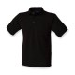
Navy Poly/Cotton 65/35%
Sherborne Tennis Club logo on the front
Sherborne Tennis Club on the back in sky
Men’s cut & women’s cut available
Juniors are unisex cut only

Cost
Adults £17.00
Juniors £16.00
Adult Sizes Mens
To fit chest size | 34” | 36” | 38/40” | 42” | 44/46” | 48” | 50/52”
Order as | XS | S | M | L | XL | 2XL | 3XL

Adult Size Ladies
To fit ladies size | 8 | 10 | 12 | 14 | 16 | 18 | 20
Order as | XS | S | M | L | XL | 2XL | 3XL

Junior Sizes
To fit chest size | 22” | 24” | 26” | 28” | 30” | 32”
Order as | 3-4 years | 5-6 years | 7-8 years | 9–10 years | 11-12 years | 13-14 years

T-Shirt
Adult sizes

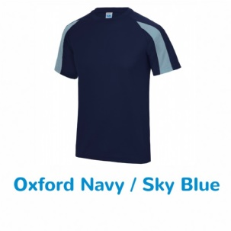
Navy ‘Cool’ performance shirt with Sky trim – 100% polyester
Sherborne Tennis Club logo on the front
Sherborne Tennis Club on the back in sky
Only Unisex cut available for this item

Cost
Adults £15.00

Adult Sizes
To fit chest size | 38” | 40” | 43” | 45” | 48”
Order as | S | M | L | XL | 2XL

Junior Sizes

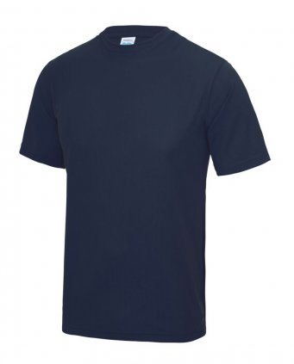
Navy ‘Cool’ performance shirt – 100% polyester
Sherborne Tennis Club logo on the front
Sherborne Tennis Club on the back in sky
Only Unisex cut available for this item

Cost
Juniors £12.00

Junior Sizes
To fit chest size | 24” | 26” | 28” | 30” | 32”
Order as | 3-4 years | 5-6 years | 7-8 years | 9-11 years | 12-13 years

Baseball Cap

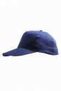
Navy cotton baseball cap
Sherborne Tennis Club logo on the front

Cost
Adults £11.00
Juniors £11.00

SunVisor
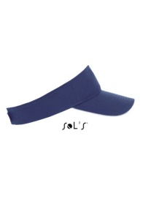
Navy cotton sun visor
Sherborne Tennis Club Logo on the front

Cost
Adults £10.50

Sherborne Tennis Club Kit Order Form

Please use this form for ordering…and complete all parts…
Thank you.

Please email to kerrynmullen@gmail.com

Name:

Contact email address:

Contact phone number:

When do you regularly go to the Club for playing/coaching sessions &/or who is your coach?

I would like to order:

Hoodie Quantity: Size: Total @ =

Sweatshirt Quantity: Size: Total @ =

Poly/Cotton Polo Shirt
Mens Quantity: Size: Total @ =

Womens Quantity: Size: Total @ =

Juniors Quantity: Size: Total @ =

Performance Polo Shirt
Unisex Quantity: Size: Total @ =

T-Shirt Quantity: Size: Total @ =

Baseball cup
Adults Quantity: Size: Total @ =

Juniors Quantity: Size: Total @ =

_______
£

Thank you for ordering some kit.

If you wish to purchase any items of kit please complete the form above email it to Kerry Mullen.
Please make a BACS payments before sending me the email so I can link the payment to the order.

Sort code: 08-92-88
Account number: 13058861
Payee name: k n mullen

Please contact me with any queries that you may have.

